|  |
| --- |
|  |
| Capstone Project Document |

**First Aid**

Report #2 – Screen Design

|  |  |  |
| --- | --- | --- |
| **First Aid** | | |
| **Group Members** | Đàm Huy Hùng | SE03431 |
| Nguyễn Duy Anh | 01525 |
| Mai Trung Kiên | SE02994 |
| Nguyễn Tiến Dũng | SE03272 |
| Nguyễn Phúc An | SE03118 |
| **Supervisor** | Mr. Nguyễn Văn Sang | |
| **Project code** | FAVN | |

**- -**

# SIGNATURE PAGE

AUTHOR: Nguyễn Phúc An 18/10/2016

Team member

REVIEWERS: Đàm Huy Hùng 18/10/2016

Project manager

APPROVAL: Nguyễn Văn Sang 19/10/2016

Supervisor

Record of change

*A - Added M - Modified D – Deleted

|  |  |  |  |  |  |
| --- | --- | --- | --- | --- | --- |
| Effective Date | Changed Item | A,M,D | Change Description | Reason for Change | Rev. Number |
| 18/Oct/2016 | Create Screen Design | A | First version | Create Screen Design | 1.0 |
|  |  |  |  |  |  |
|  |  |  |  |  |  |
|  |  |  |  |  |  |
|  |  |  |  |  |  |
|  |  |  |  |  |  |
|  |  |  |  |  |  |
|  |  |  |  |  |  |
|  |  |  |  |  |  |
|  |  |  |  |  |  |
|  |  |  |  |  |  |
|  |  |  |  |  |  |
|  |  |  |  |  |  |
|  |  |  |  |  |  |
|  |  |  |  |  |  |
|  |  |  |  |  |  |
|  |  |  |  |  |  |
|  |  |  |  |  |  |
|  |  |  |  |  |  |
|  |  |  |  |  |  |
|  |  |  |  |  |  |
|  |  |  |  |  |  |
|  |  |  |  |  |  |
|  |  |  |  |  |  |

Contents

SIGNATURE PAGE 0

Introduction 3

1.1 Purpose 3

1.2 Definitions, Acronyms and Abbreviations 3

1.3 Overview 3

2 Screen Flow 3

2.1 First Aid Application 4

2.1.1 Emergency Screen 4

2.1.2 Learning Screen 9

2.1.3 More 14

2.1.4 Software information 17

2.2 Ambulance 19

2.2.1 Login 19

2.2.2 Waiting 21

2.2.3 Task 21

2.3 Dispatcher 23

2.3.1 Login 23

2.3.2 Dispatcher’s Dashboard 24

2.4 Admin 26

2.4.1 Login 26

2.4.2 User 27

2.4.3 Add new user 28

2.4.4 Edit user 29

2.4.5 Question-Answer 30

# Introduction

## Purpose

Make the user can more clearly understand the flow of the screen in a product of the system. To ensure consistency and simplicity in detailed design across all displays within a product interface of the system. Definitions, acronyms, abbreviations, references and overview of each application of FAVN system.

## Definitions, Acronyms and Abbreviations

|  |  |  |
| --- | --- | --- |
| Abbreviations | Description | Comment |
| FAVN | First Aid Viet Nam |  |
| Q&A | Question and Answer |  |

Table 1-1: Definitions, Acronyms and Abbreviations

## Overview

# Screen Flow

## First Aid Application

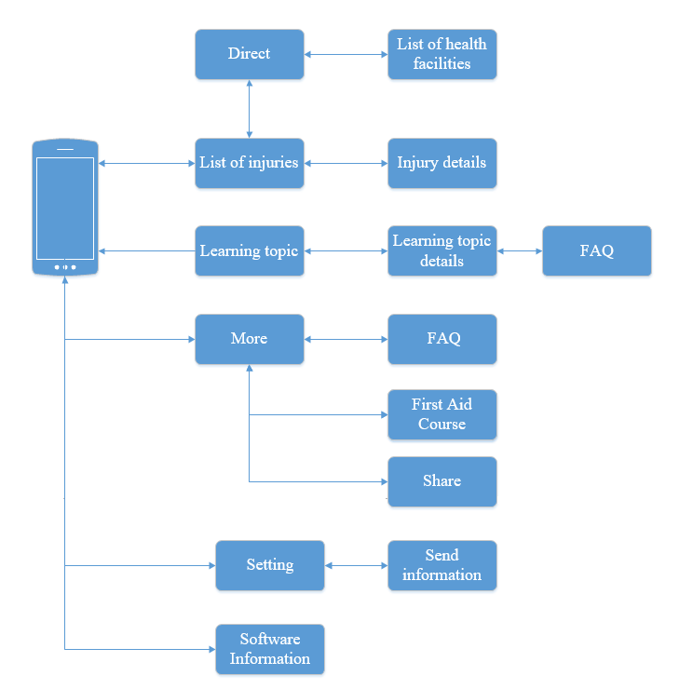

1. First Aid Screen Flow

### Emergency Screen

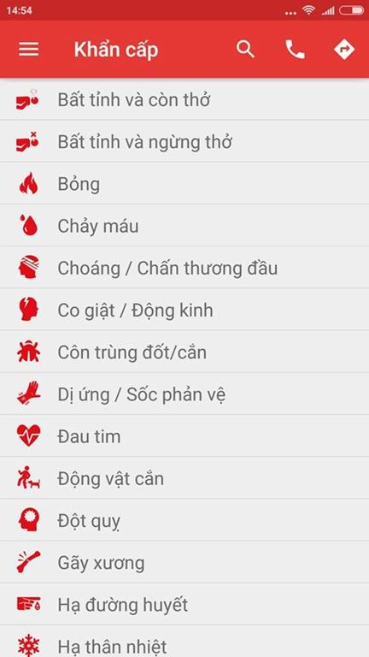

1. Emergency Screen

|  |  |  |  |  |  |  |  |  |
| --- | --- | --- | --- | --- | --- | --- | --- | --- |
| No | Field name | | Field name in Vietnamese | Type | Require | Mandatory | Max-Length | Description |
|  | Menu Bar | Menu | | Button | Tap on | Y |  | Show list of screen |
|  | Search | Tìm Kiếm | | Icon | Tap on | Y |  | Show textbox to input characters |
|  | Call | Gọi | | Icon | Tap on | Y |  | Auto dialing 115 |
|  | Direct | Chỉ đường | | Icon | Tap on | Y |  | Move to screen Direct. |
|  | List of injuries | Danh sách các trường hợp khẩn cấp | | List |  | Y |  | Show list of emergency. |

1. EmergencyScreen

#### Emergency Details

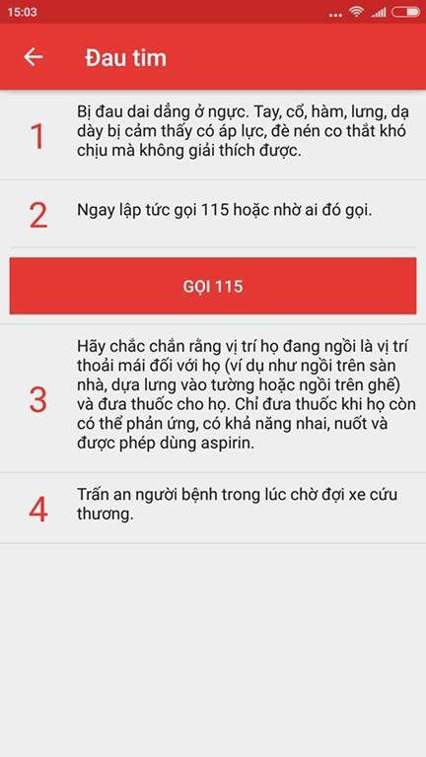

Figure 2-3: Emergency Details

|  |  |  |  |  |  |  |  |  |
| --- | --- | --- | --- | --- | --- | --- | --- | --- |
| No | Field name | Field name in Vietnamese | Type |  | Require | Mandatory | Max-Length | Description |
| 1 | Back button | Nút quay lại | Button |  | Tap on | Y |  | Back to screen emergency |
| 2 | Call 115 | Gọi 115 | Button |  | Tap on | Y |  | Call 115 |

**Table 2-2: Emergency Details**

#### Direct screen

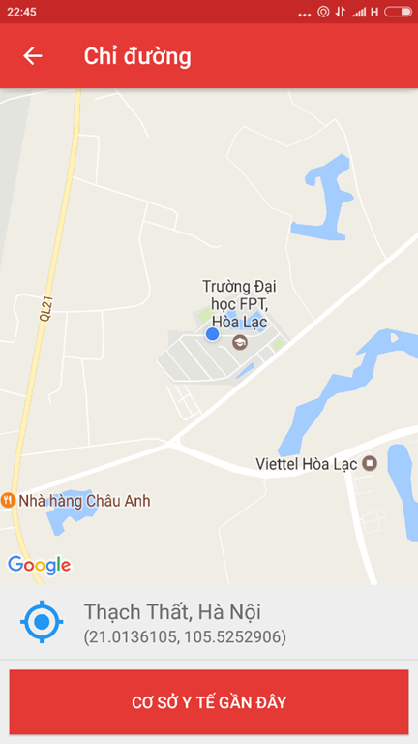

**Figure 2-4: Direct Screen**

|  |  |  |  |  |  |  |  |
| --- | --- | --- | --- | --- | --- | --- | --- |
| No | Field name | Field name in Vietnamese | Type | *Require* | Mandatory | Max-Length | Description |
| 1 | Current location | Vị trí hiện tại | Button | Tap on | Y |  | Focus to current location |
| 2 | Nearly health facilities | Cơ sở y tế gần đây | Button | Tap on | Y |  | Show the list of 20 nearest health facilites |
| 3 | Back button | Nút quay lại | Button | Tap on | Y |  | Back to the previous screen |

**Table 2-3: Direct**

#### List of health facilities

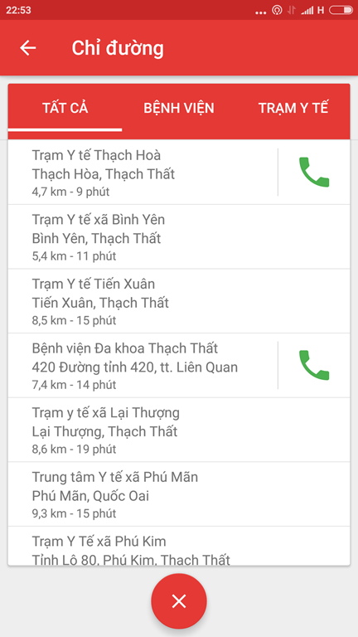

**Figure 2-5: List of health facilities screen**

|  |  |  |  |  |  |  |  |
| --- | --- | --- | --- | --- | --- | --- | --- |
| No | Field name | Field name in Vietnamese | Type | Require | Mandatory | Max-Length | Description |
| 1 | List of health facilities | Danh sách các cơ sở y tế | List |  | Y |  | List health facilities |
| 2 | Close | Tắt | Button | Tap on | Y |  | Turn off the list of health facilities |
| 3 | Hospital | Bệnh viện | Button | Tap on | Y |  | Show list of hospitals |
| 4 | Medicine Center | Trạm Y Tế | Button | Tap on | Y |  | Show list of medicine center |

**Table 2-4: List of health facilities screen**

### Learning Screen

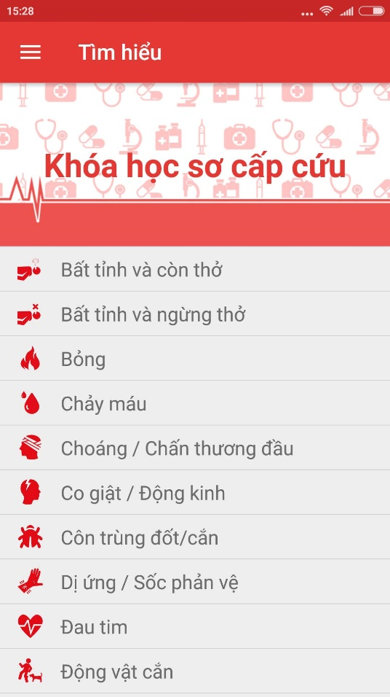

Figure 2-6: Learning screen

|  |  |  |  |  |  |  |  |
| --- | --- | --- | --- | --- | --- | --- | --- |
| No | Field name | Field name in Vietnamese | Type | Require | Mandatory | Max-Length | Description |
| 1 | List of learning topic | Danh sách các chủ đề tìm hiểu | List |  | Y |  | Display list of learning topic |
| 2 | First Aid Course | Các khóa học sơ cứu | Image link | Tap on | Y |  | Show the list of First Aid Course |

Table 2-5: Learning screen

#### Learning topic details screen

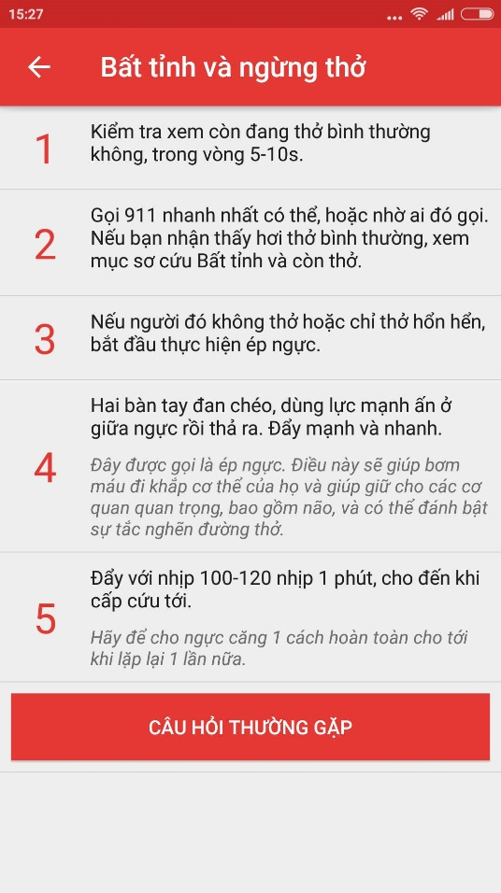

**Figure 2-7: Learning Topic Details**

|  |  |  |  |  |  |  |  |
| --- | --- | --- | --- | --- | --- | --- | --- |
| No | Field name | Field name in Vietnamese | Type | Require | Mandatory | Max-Length | Description |
| 1 | Back Button | Nút quay lại | Button | Tap on | Y |  | Back to Learning screen |
| 2 | Step | Bước làm | Button | Tap on |  |  | Read the content of step |
| 3 | FAQ | Câu hỏi thường gặp | Button | Tap on | Y |  | Show the list of FAQ |

**Table 2-6: Learning Topic Details**

#### FAQ screen

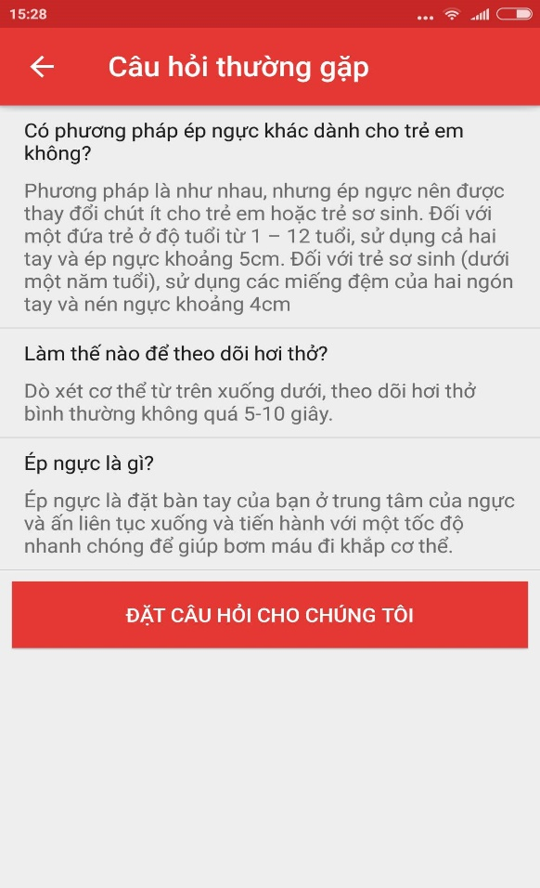

Figure 2-8: FAQ screen

|  |  |  |  |  |  |  |  |
| --- | --- | --- | --- | --- | --- | --- | --- |
| No | Field name | Field name in Vietnamese | Type | Require | Mandatory | Max-Length | Description |
| 1 | Back button | Nút quay lại | Button | Tap on | Y |  | Back to Learning Topic Details screen |
| 3 | List of question and answers | Danh sách các câu hỏi và câu trả lời | List |  | Y |  | Show list of FAQ |
| 4 | Button Ask a question | Đặt câu hỏi cho chúng tôi | Button | Tap on | Y |  | Move to screen to send the questions. |

Table 2-7: FAQ screen

#### Ý Kiến - Hỏi Đáp screen

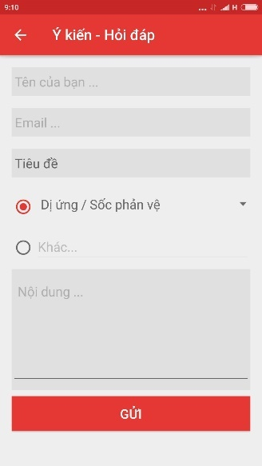

Figure 2-9: Send question screen

|  |  |  |  |  |  |  |  |
| --- | --- | --- | --- | --- | --- | --- | --- |
| No | Field name | Field name in Vietnamese | Type | Require | Mandatory | Max-Length | Description |
| 1 | Your name | Tên của bạn | Textfield | Tap on | Y |  | Display text |
| 2 | Email | Thư điện tử | Textfield | Tap on | Y |  | Display text |
| 3 | Title | Tiêu đề | Button | Tap on | Y |  | Display tittle |
| 4 | Content | Nội dung | Textfield | Tap on | Y |  | Display text |
| 5 | Send | Gửi | Button | Tap on |  |  | Send question to system |
| 6 | Back | Quay lại | Button | Tap on | Y |  | Back to previous screen |

Table 2-8: Send question screen

### More

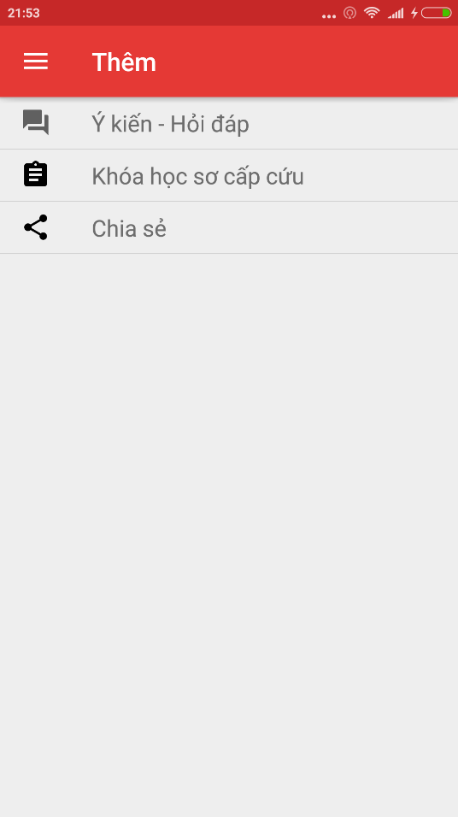

Figure 2-10: More screen

|  |  |  |  |  |  |  |  |
| --- | --- | --- | --- | --- | --- | --- | --- |
| No | Field name | Field name in Vietnamese | Type | Require | Mandatory | Max-Length | Description |
| 1 | FAQ | Ý Kiến – Hỏi Đáp | Button |  | Y |  | Move to FAQ screen |
| 2 | First Aid Courses | Các khóa học sơ cứu | Button |  | Y |  | Move to list of First Aid Courses |
| 3 | Share | Chia sẻ | Label |  | Y |  | Share application on communication social network |

Table 2-9: More screen

#### FAQ screen



Figure 2-11: Send Question

|  |  |  |  |  |  |  |  |
| --- | --- | --- | --- | --- | --- | --- | --- |
| No | Field name | Field name in Vietnamese | Type | Require | Mandatory | Max-Length | Description |
| 1 | Your name | Tên của bạn | Textfield | Tap on | Y |  | Display text |
| 2 | Email | Thư điện tử | Textfield | Tap on | Y |  | Display text |
| 3 | Title | Tiêu đề | Button | Tap on | Y |  | Display tittle |
| 4 | Content | Nội dung | Textfield | Tap on | Y |  | Display text |
| 5 | Send | Gửi | Button | Tap on | Y |  | Send question to system |
| 6 | Back | Quay lại | Button | Tap on | Y |  | Back to previous screen |

Table 2-10: Send Question

#### First Aid Courses screen

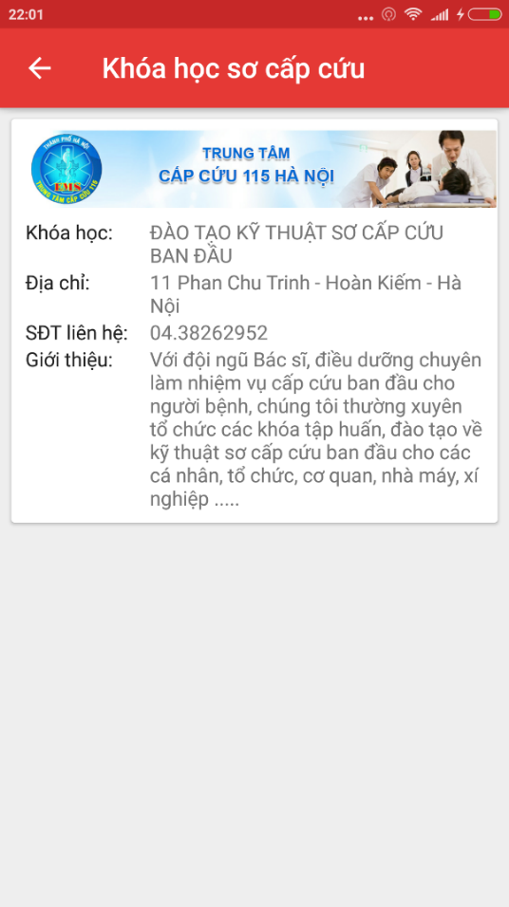

**Figure 2-12: First Aid Course Information**

|  |  |  |  |  |  |  |  |
| --- | --- | --- | --- | --- | --- | --- | --- |
| No | Field name | Field name in Vietnamese | Type | Require | Mandatory | Max-Length | Description |
| 1 | List of First Aid Courses | Danh sách khóa học sơ cứu | Card view |  | Y |  | Display text |

**Table 2-11: First Aid Course Information**

### Software information

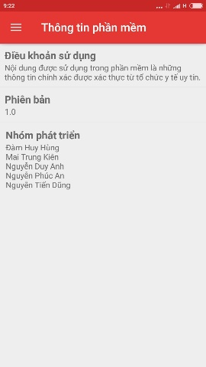

**Figure 2-13: Software information screen**

|  |  |  |  |  |  |  |  |
| --- | --- | --- | --- | --- | --- | --- | --- |
| No | Field name | Field name in Vietnamese | Type | Require | Mandatory | Max-Length | Description |
| 1 | Term of use | Điều khoản sử dụng | Card view |  | Y |  | Show term of use |
| 2 | Version | Phiên bản | Card view |  | Y |  | Show the version of software |
| 3 | Name of developers | Tên nhà phát triển | Card view |  | Y |  | Show the name of developers. |

**Table 2-12: Software information screen**

## Ambulance

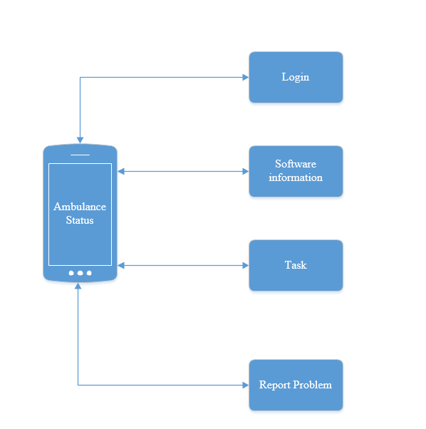

**Figure 2-14: Ambulance screen flow**

### Login

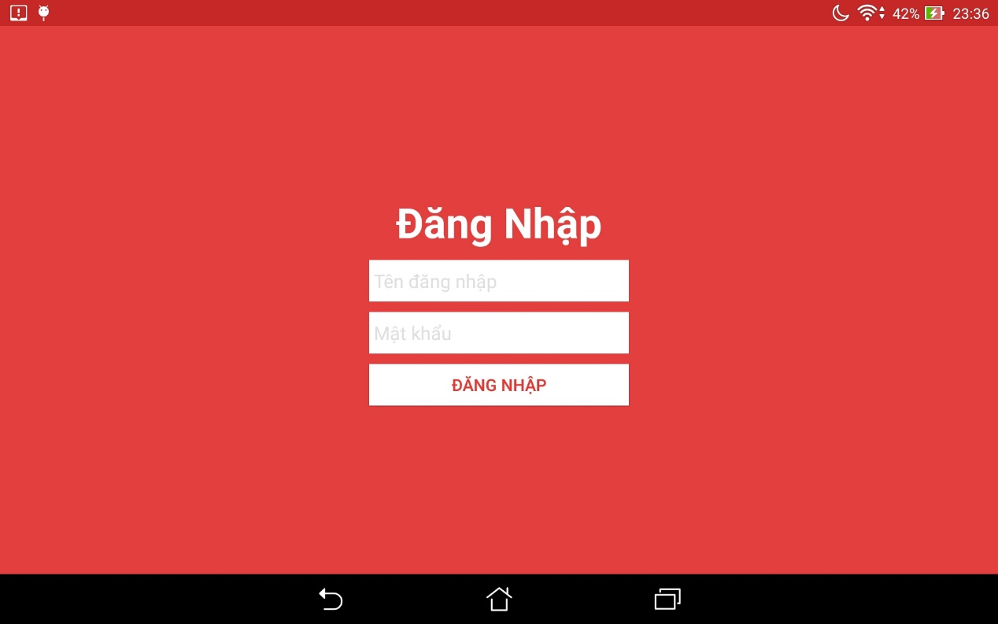

**Figure 2-15: Login screen**

|  |  |  |  |  |  |  |  |
| --- | --- | --- | --- | --- | --- | --- | --- |
| No | Field name | Field name in Vietnamese | Type | Require | Mandatory | Max-Length | Description |
| 1 | Login | Đăng Nhập | Button | Click on | Y |  | Login |
| 2 | User name | Tên đăng nhập | Textfield | Click on | Y |  | Fill the user name |
| 3 | Password | Mật Khẩu | Textfield | Click on | Y |  | Fill the password |

**Table 2-13: Login screen**

### Waiting

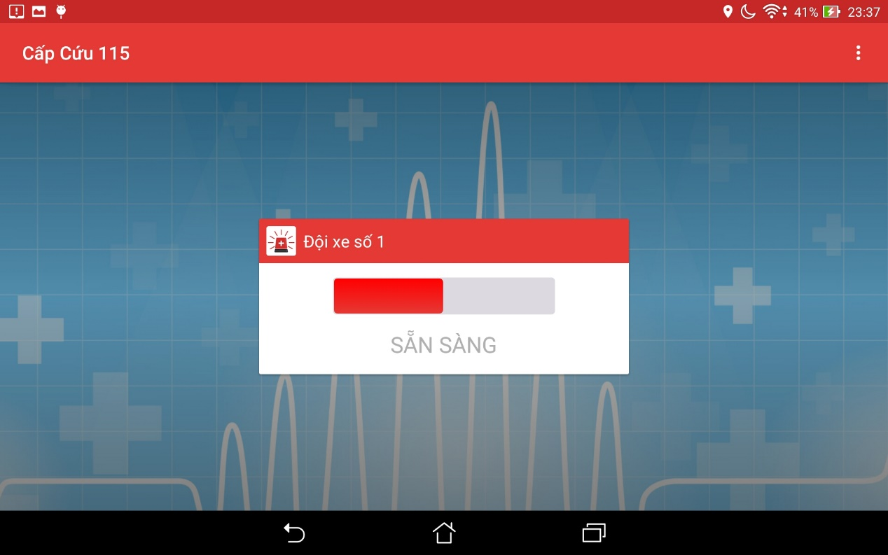

**Figure 2-16: Waiting Screen**

|  |  |  |  |  |  |  |  |
| --- | --- | --- | --- | --- | --- | --- | --- |
| No | Field name | Field name in Vietnamese | Type | Require | Mandatory | Max-Length | Description |
| 1 | Ready to take the task | Sẵn sàng nhận nhiệm vụ | Switch | Tap on | Y |  | Show the status of user ready to take the task or not |
| 2 | Menu | Tùy Chọn | Dropdown list | Tap on | Y |  | Show two button [Đăng Xuất] and [Thông tin phần mềm |

**Table 2-14: Waiting Screen**

### Task

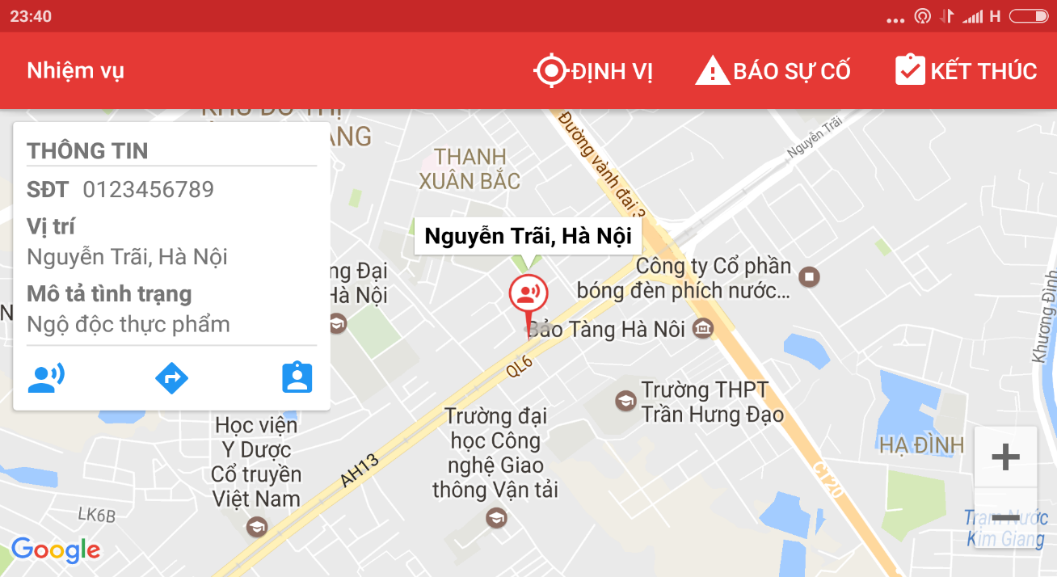

**Figure 2-17: Task screen**

|  |  |  |  |  |  |  |  |
| --- | --- | --- | --- | --- | --- | --- | --- |
| No | Field name | Field name in Vietnamese | Type | Require | Mandatory | Max-Length | Description |
| 1 | Task | Nhiệm vụ | Label |  | Y |  | Name of screen |
| 2 | Locate | Định vị | Icon | Tap on | Y |  | Locate position of ambulance team |
| 3 | Information board | Bảng thông tin | Text |  | Y |  | Show the information of victims |
| 4 | Victim current position | Vị trí hiện tại của nạn nhân | Icon | Tap on | Y |  | Location position of victim |
| 5 | Direct | Chỉ Đường | Icon | Tap on | Y |  | Show the direct from ambulance team to the victim, include distance |
| 6 | Report problem | Báo Cáo Sự Cố | Icon | Tap on | Y |  | Call the center to report problem |
| 7 | Finish | Kết thúc | Icon | Tap on | Y |  | Report that mission completed or cancel |

**Table 2-15: Task screen**

## Dispatcher

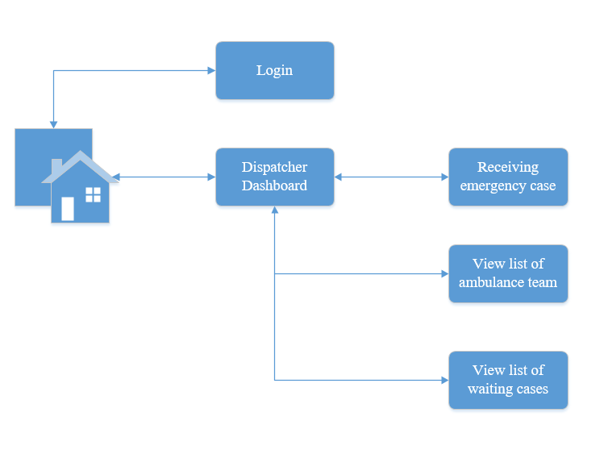

**Figure 2-17: Dispatcher screen flow**

### Login

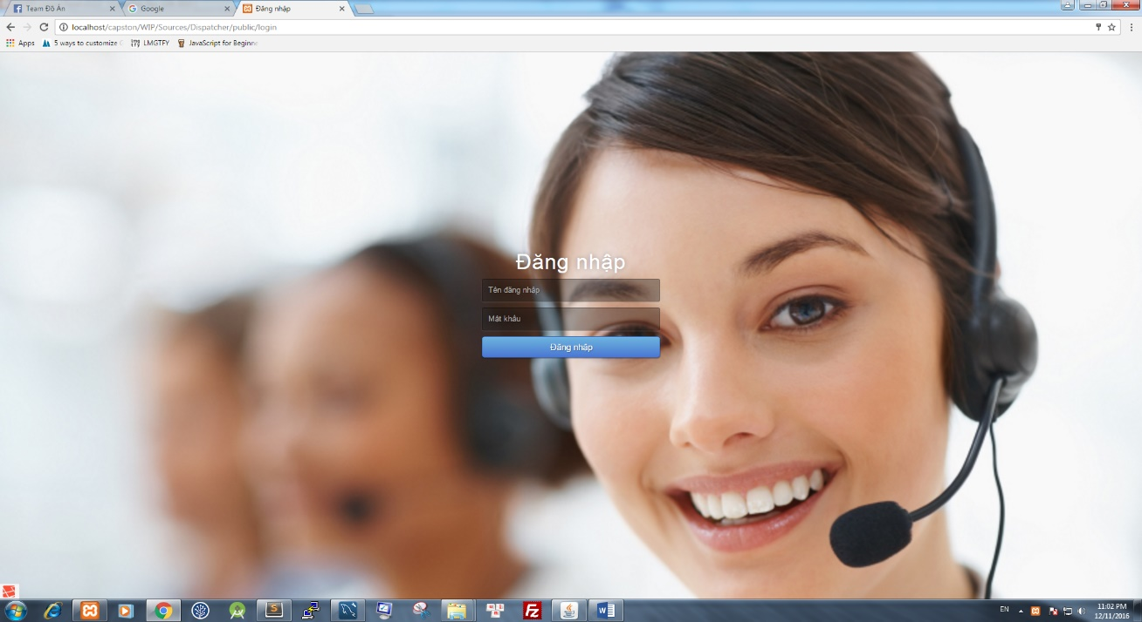

**Figure 2-18: Login screen**

|  |  |  |  |  |  |  |  |
| --- | --- | --- | --- | --- | --- | --- | --- |
| No | Field name | Field name in Vietnamese | Type | Require | Mandatory | Max-Length | Description |
| 1 | Login | Đăng Nhập | Button | Click on | Y |  | Login to the dispatcher dashboard page |
| 2 | User name | Tên đăng nhập | Textfield | Click on | Y |  | Fill the user name |
| 3 | Password | Mật Khẩu | Textfield | Click on | Y |  | Fill the password |

**Table 2-16: Login screen**

### Dispatcher’s Dashboard

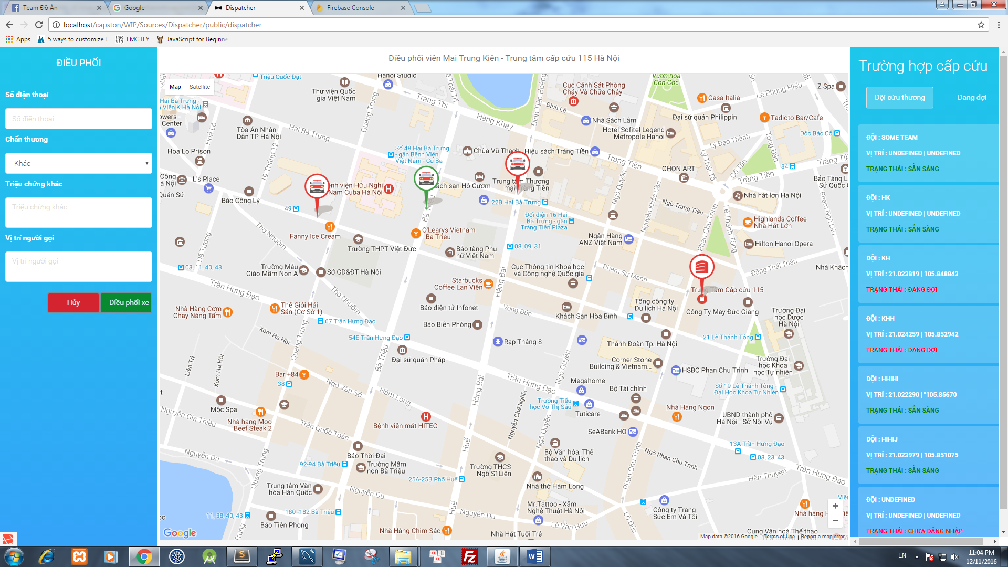

**Figure 2-19: Dispatcher’s Dashboard screen**

|  |  |  |  |  |  |  |  |
| --- | --- | --- | --- | --- | --- | --- | --- |
| No | Field name | Field name in Vietnamese | Type | Require | Mandatory | Max-Length | Description |
| 1 | Phone number | Số Điện Thoại | Text field | Click on | Y | 11 | Fill phone number of caller. |
| 2 | Injury | Chấn Thương | Dropdown list | Click on | Y |  | Show list of injuries |
| 3 | Caller’s Position | Vị trí người gọi | Text field | Click on | Y |  | Fill the position of caller. |
| 4 | Other injuries | Chấn Thương khác | Text field | Click on | Y |  | Fill the injury |
| 5 | Dispatch | Điều phối xe | Button | Click on | Y |  | Dispatch the ambulance for the emergency cases |
| 6 | Cancel | Hủy | Button | Click on | Y |  | Cancel the emergency case |
| 7 | Ambulance Team | Đội cứu thương | Button | Click on | Y |  | Show list of ambulance, include ambulance information |
| 8 | Waiting | Đang đợi | Button | Click on | Y |  | Show list of waiting cases |

**Table 2-17: Dispatcher’s Dashboard screen**

## Admin

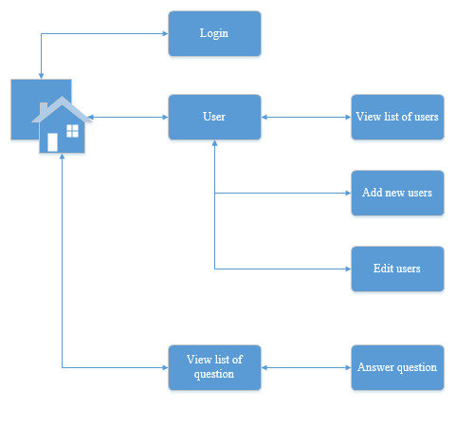

**Figure 2-20: Admin screen flow**

### Login

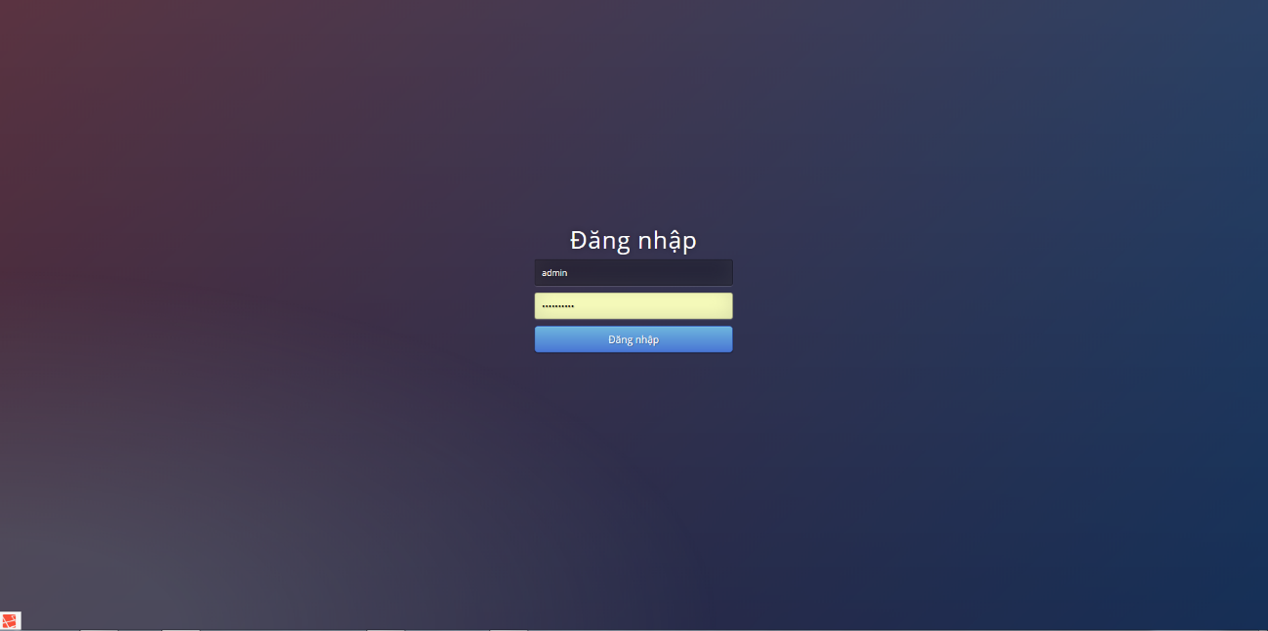

**Figure 2-21: Login screen**

|  |  |  |  |  |  |  |  |
| --- | --- | --- | --- | --- | --- | --- | --- |
| No | Field name | Field name in Vietnamese | Type | Require | Mandatory | Max-Length | Description |
| 1 | Login | Đăng Nhập | Button | Click on | Y |  | Login to the admin dashboard page |
| 2 | User name | Tên đăng nhập | Textfield | Click on | Y |  | Fill the user name |
| 3 | Password | Mật Khẩu | Textfield | Click on | Y |  | Fill the password |

**Table 2-18: Login screen**

### User

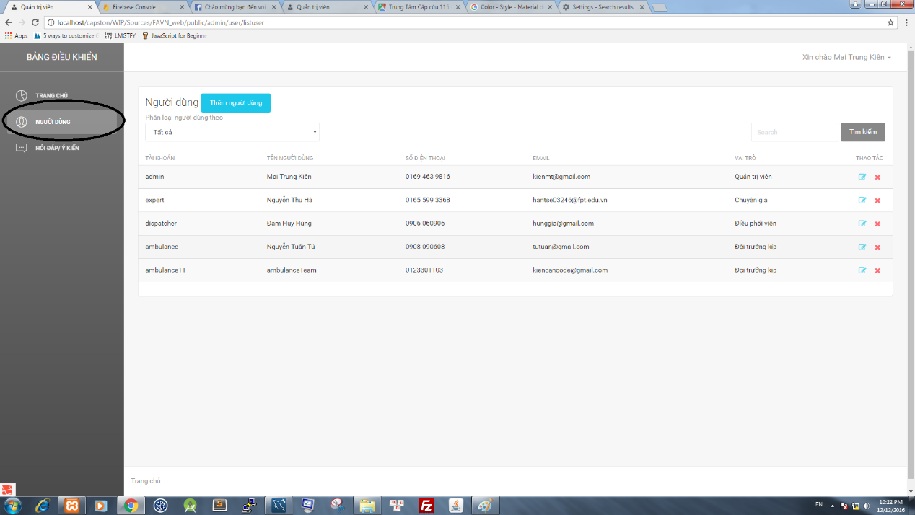

**Figure 2-22: User screen**

|  |  |  |  |  |  |  |  |
| --- | --- | --- | --- | --- | --- | --- | --- |
| No | Field name | Field name in Vietnamese | Type | Require | Mandatory | Max-Length | Description |
| 1 | Add new user | Thêm người dùng | Button | Click on | Y |  | Move to add new user page |
| 2 | Edit | Sửa người dùng | Icon | Click on | Y |  | Move to edit user page |
| 3 | Delete | Xóa người dùng | Icon | Click on | Y |  | Delete user |
| 4 | User Classification | Phân loại người dùng | Dropdownlist | Click on | Y |  | Classification user by role |
| 5 | Search textbox | Ô tìm kiếm | Textbox | Click on | Y |  | Input characters to search users |
| 6 | Search button | Nút tìm kiếm | Button | Click on | Y |  | Search users |

**Table 2-19: User screen**

### Add new user

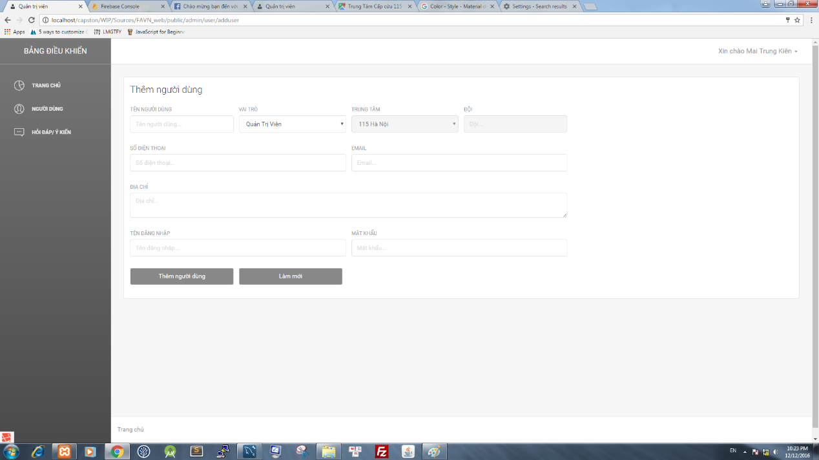

**Figure 2-23: Add new user screen**

|  |  |  |  |  |  |  |  |
| --- | --- | --- | --- | --- | --- | --- | --- |
| No | Field name | Field name in Vietnamese | Type | Require | Mandatory | Max-Length | Description |
| 1 | User name | Tên người dùng | Textfield | Click on | Y |  | Fill name of user |
| 2 | Role | Vai trò | Dropdownlist | Click on | Y |  | Select role of user |
| 3 | Center | Trung Tâm | Dropdownlist | Click on | Y |  | Select center |
| 4 | Team | Đội | Textfield | Click on | Y |  | Fill name of ambulance team |
| 5 | Phone number | Số Điện Thoại | Textfield | Click on | Y |  | Fill phone number of user |
| 6 | Email | Thư điện tử | Text field | Click on | Y |  | Fill email of user |
| 7 | Address | Địa chỉ | Text field | Click on | Y |  | Fill address of user |
| 8 | Login name | Tên đăng nhập | Text field | Click on | Y |  | Fill login name of user |
| 9 | Password | Mật Khẩu | Text  field | Click on | Y |  | Fill password of user |
| 10 | Add new user | Thêm người dung | Button | Click on | Y |  | Add new user |
| 11 | Reset | Làm mới | Button | Click on | Y |  | Reset all text field |

**Table 2-20: Add new user screen**

### Edit user

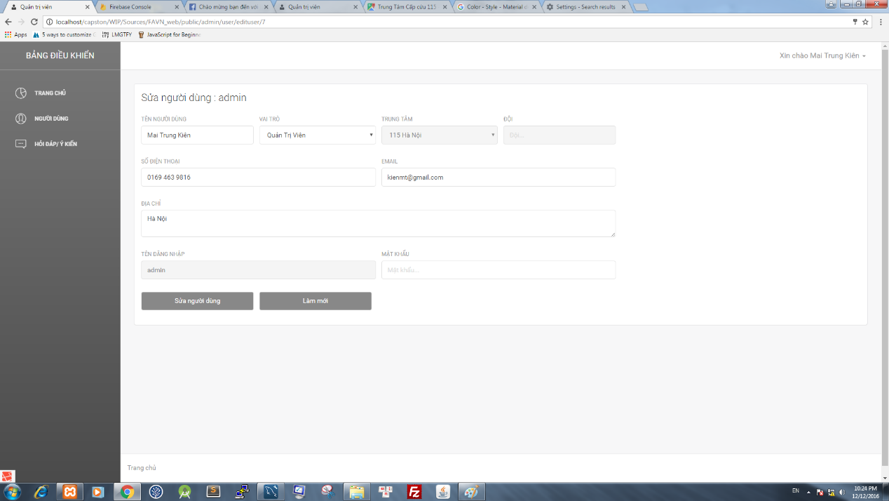

**Figure 2-24: Edit user screen**

|  |  |  |  |  |  |  |  |
| --- | --- | --- | --- | --- | --- | --- | --- |
| No | Field name | Field name in Vietnamese | Type | Require | Mandatory | Max-Length | Description |
| 1 | User name | Tên người dùng | Textfield | Click on | Y |  | Edit name of user |
| 2 | Role | Vai trò | Dropdownlist | Click on | Y |  | Select role of user |
| 3 | Center | Trung Tâm | Dropdownlist | Click on | Y |  | Select center |
| 4 | Team | Đội | Textfield | Click on | Y |  | Edit name of ambulance team |
| 5 | Phone number | Số Điện Thoại | Textfield | Click on | Y |  | Edit phone number of user |
| 6 | Email | Thư điện tử | Text field | Click on | Y |  | Edit email of user |
| 7 | Address | Địa chỉ | Text field | Click on | Y |  | Edit address of user |
| 8 | Login name | Tên đăng nhập | Text field | Click on | Y |  | Edit login name of user |
| 9 | Password | Mật Khẩu | Text  field | Click on | Y |  | Edit password of user |
| 10 | Add new user | Thêm người dung | Button | Click on | Y |  | Add new user |
| 11 | Reset | Làm mới | Button | Click on | Y |  | Reset all text field |

**Table 2-21: Edit user screen**

### Question-Answer

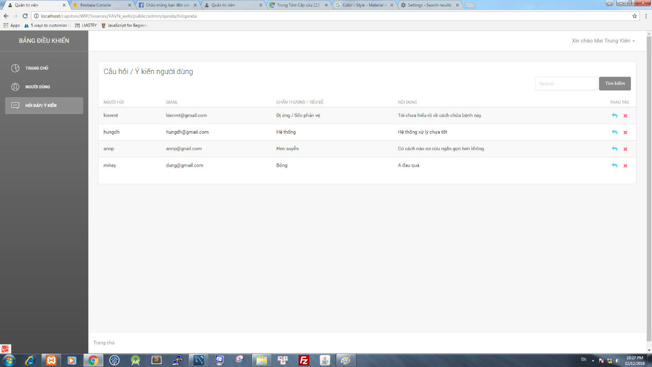 **Figure 2-25: Question-Answer screen**

|  |  |  |  |  |  |  |  |
| --- | --- | --- | --- | --- | --- | --- | --- |
| No | Field name | Field name in Vietnamese | Type | Require | Mandatory | Max-Length | Description |
| 1 | Answer Question | Trả lời câu hỏi | Icon | Click on | Y |  | Move to edit answer question page |
| 2 | Delete | Xóa câu hỏi | Icon | Click on | Y |  | Delete question |
| 3 | Search textbox | Ô tìm kiếm | Textbox | Click on | Y |  | Input characters to search users |
| 4 | Search button | Nút tìm kiếm | Button | Click on | Y |  | Search question |

**Table 2-22: Question-Answer screen**